***Computer Organization***

**Lab 4 Report**

***Names:***

**عبد الرحمن إسماعيل محمد حسن (22010866)**

**نور الدين اكرم السيد كامل سيف (22011309)**

**Introduction**

This project demonstrates the use of an Arduino to measure voltage levels and trigger an alert based on specified thresholds, where a potentiometer acts as a variable voltage input.

**Implementation Setup**

* Arduino UNO microcontroller board.
* Potentiometer (50 kΩ) to provide variable voltage input.
* Buzzer for audio alerts.
* Jumper wires for circuit connections.
* Breadboard for building the circuit.
* Arduino IDE for programming the microcontroller.

**Implementation Details**

* The Arduino reads the analog input from the potentiometer, which provides a value between 0 and 1023
* To convert this reading into an actual voltage, the analog input value is multiplied by a scaling factor derived from the maximum input voltage (5V). The formula is:
* The system continually checks the converted voltage reading against predefined thresholds:
  + Upper Threshold (3V): When the voltage exceeds 3V, the system enters an "alarm state" where both the buzzer and LED are turned ON.
  + Lower Threshold (2.5V): When the voltage falls below 2.5V, the system reverts to a "normal state" with both the buzzer and LED turned OFF.
  + Between upper and lower thresholds: If the system is transitioning from an alarm state it remains on an alarm state, if the system is transitioning from a normal state it remains in a normal state.

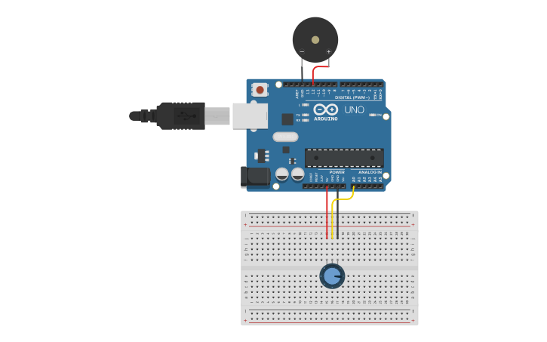**Circuit Layout Diagram**

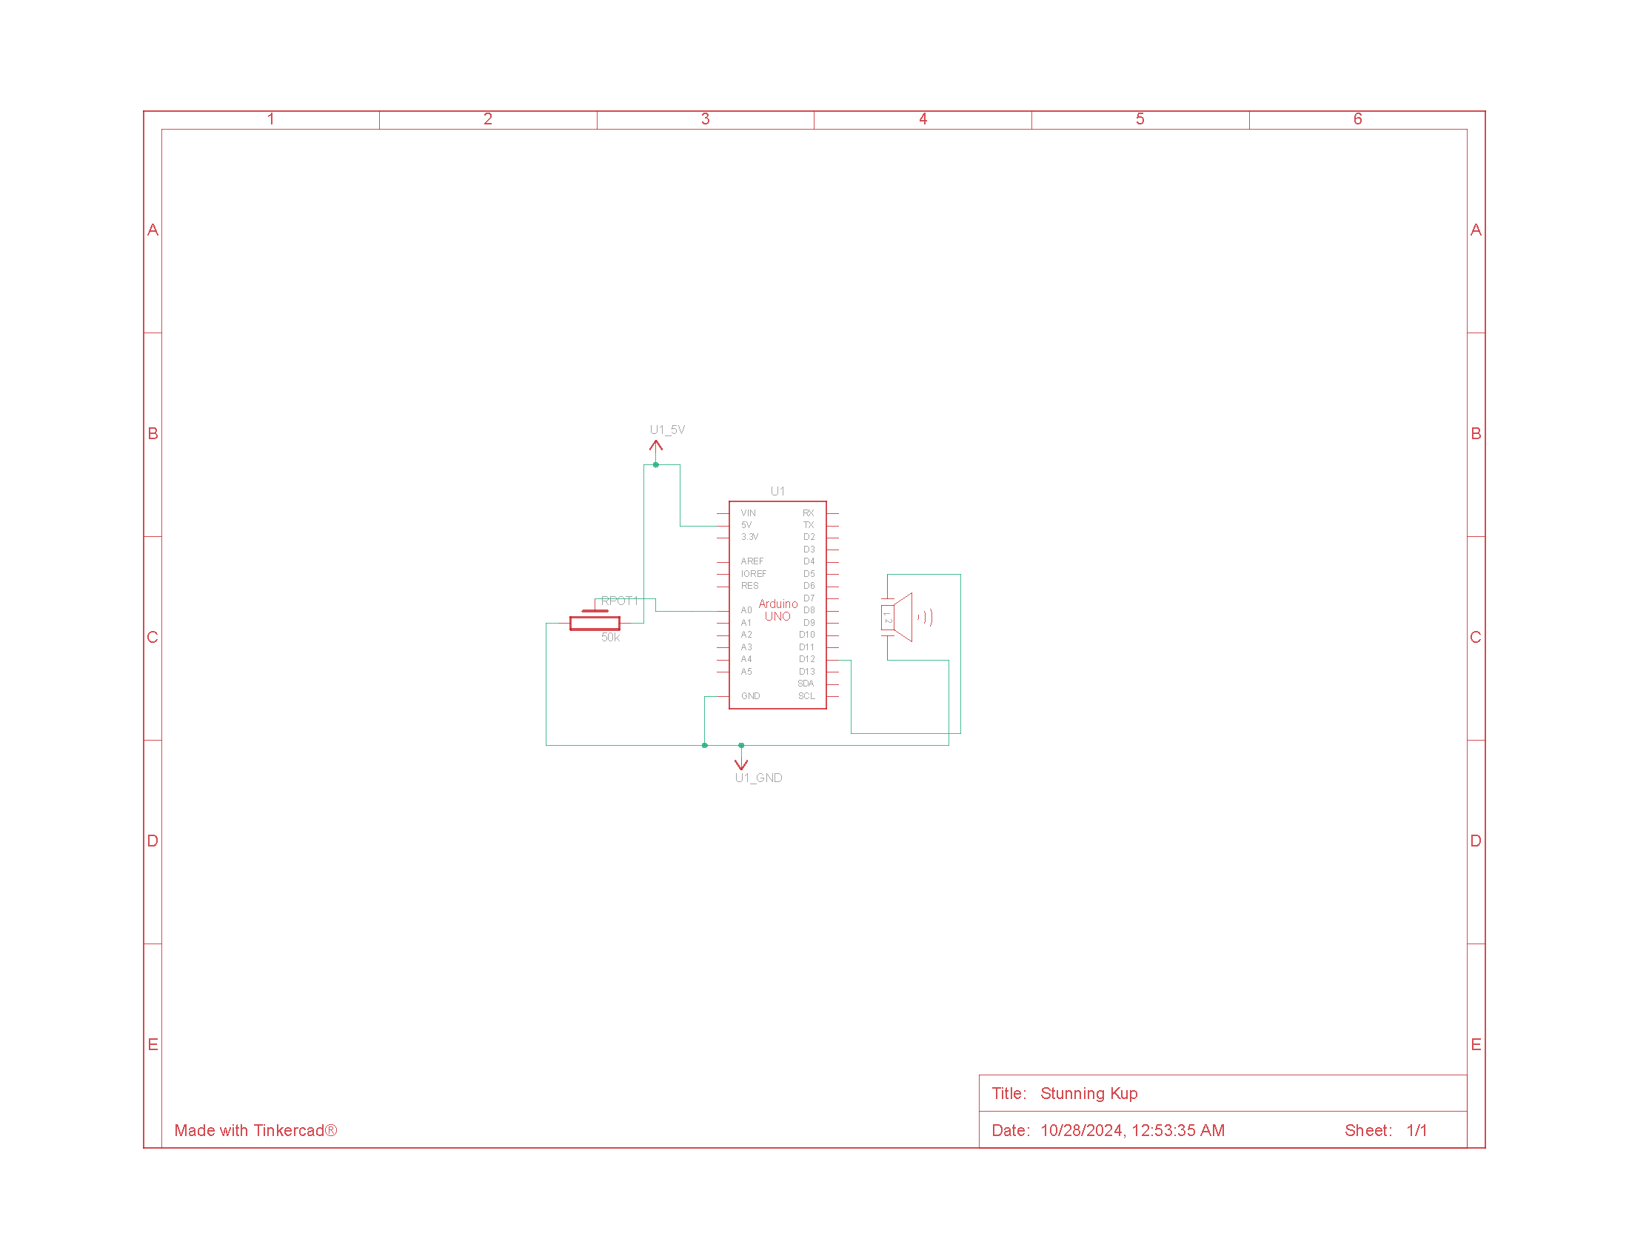**Circuit Schematic Diagram**